PRT661 – Data Science Practice | Australian Electricity Demand Forecasting | WP4
Sudip Lamichhane — WP4 Individual Contribution & Progress Report
Dan6 Theme 2 (Group 2) | Final modelling analysis, deep-learning evaluation and production model selection
Table 1. Student and WP4 role
Student | ID | WP4 role | Workstream / pair
Sudip Lamichhane | S388085 | GRU training controls, temporal information boundaries and provenance | GRU pair with Suraj Raut (sequence / recursion); primary for leakage review; co-owner of production hand-off

Evidence note
Numerical statements in this report come from the full academic run of Energy_Demand_Forecasting_Pipeline.py v4.0.0 (EnergyForecast_Run_20260929_145931, 426.7 minutes, status COMPLETE). Methodology statements refer to the same pipeline version.
The WP4 module attributed to Sudip is a current role-aligned collaboration artefact prepared from the team's integrated implementation for genuine branch-based review and merging. It does not claim or back-date earlier authorship. At the date of this report the module has been prepared and verified against the pipeline; the GitHub issue, branch, pull request and review described below are the next collaboration step and have not yet been created. Earlier-stage contributions follow the role boundaries recorded in the WP3 documents and the Meeting 6 minutes.

1. Allocated WP4 responsibility
Sudip's WP4 responsibility is how the GRU is trained and what it is allowed to know. In earlier stages he owned the WA/WEM acquisition path, source quality and provenance, SARIMA/SARIMAX and weather-vintage governance; WP4 carries that provenance focus into the neural model. The scope covers the GRU architecture, TensorFlow training controls, deterministic seeds, target and feature scaling, the validation period, weather/context provenance, information-boundary validation, convergence and failure capture, and the learning-history output. He also leads the leakage and information-boundary review for the whole WP4 module set.

2. Training and boundary controls
Table 2. GRU training and information-boundary controls
Control | Setting in pipeline v4.0.0 | What it prevents
Architecture | GRU(64) encoder → Dropout 0.2 → repeated for 48 steps + 41 known-future features → Dense 64 ReLU → Dense 1 per step; 20,673 parameters | —
Loss / optimiser | Huber (δ = 0.5), Adam 1e-3, batch 128 | Large misses dominating training
Validation period | Sequences starting in the last 56 days before the origin; training sequences must end before that block | Straddling sequences; tuning on the horizon
Early stopping / LR | EarlyStopping (patience 6, best weights), ReduceLROnPlateau, 30-epoch budget | Over-training
Refit | All pre-origin sequences for the best epoch count, replaying the LR path | Losing the final eight weeks
Scaling | Target and decoder scalers fitted before the training limit only | Scaler statistics from the future
Seeds | stable_seed(region, model, origin); TF deterministic ops | Irreproducible runs
Weather provenance | Horizon rows carry BACKTEST_CLIMATOLOGY with information origin = forecast origin | Realised weather entering a backtest

3. Training and provenance evidence from the final run
Table 3. GRU training and provenance evidence
Evidence | Result | Source
GRU runs completed | 24 of 24 region-origins (warnings only in 2022) | model_comparison_by_year.csv
Best epoch | mean 22.6 of 30; 14 of 24 fits reached the 30-epoch limit (GRU_L672: 17 of 24) | neural_training_history.csv
Learning-rate reductions | triggered in 20 of 24 GRU fits | neural_training_history.csv
Training time | mean 261 s fit per run (GRU_L672 627 s) vs about 4–5 s for Random Forest fit | computational_cost.csv
Leakage audit | 9 PASS + 5 DESIGN_CONTROL (incl. GRU sequence boundary: DESIGN_CONTROL + RUNTIME_ASSERT) | leakage_audit.csv
Balance point | Re-derived per origin: 18 full searches + 6 short-history estimates (2022); 16.5–19.5 °C | origin_feature_rebuild_checks.csv
Statistical models (earlier role) | SARIMAX 14 failed runs (12 divergence-guard, 2 exogenous NaN in 2022); SARIMA 3 non-convergence warnings | model_failures.csv

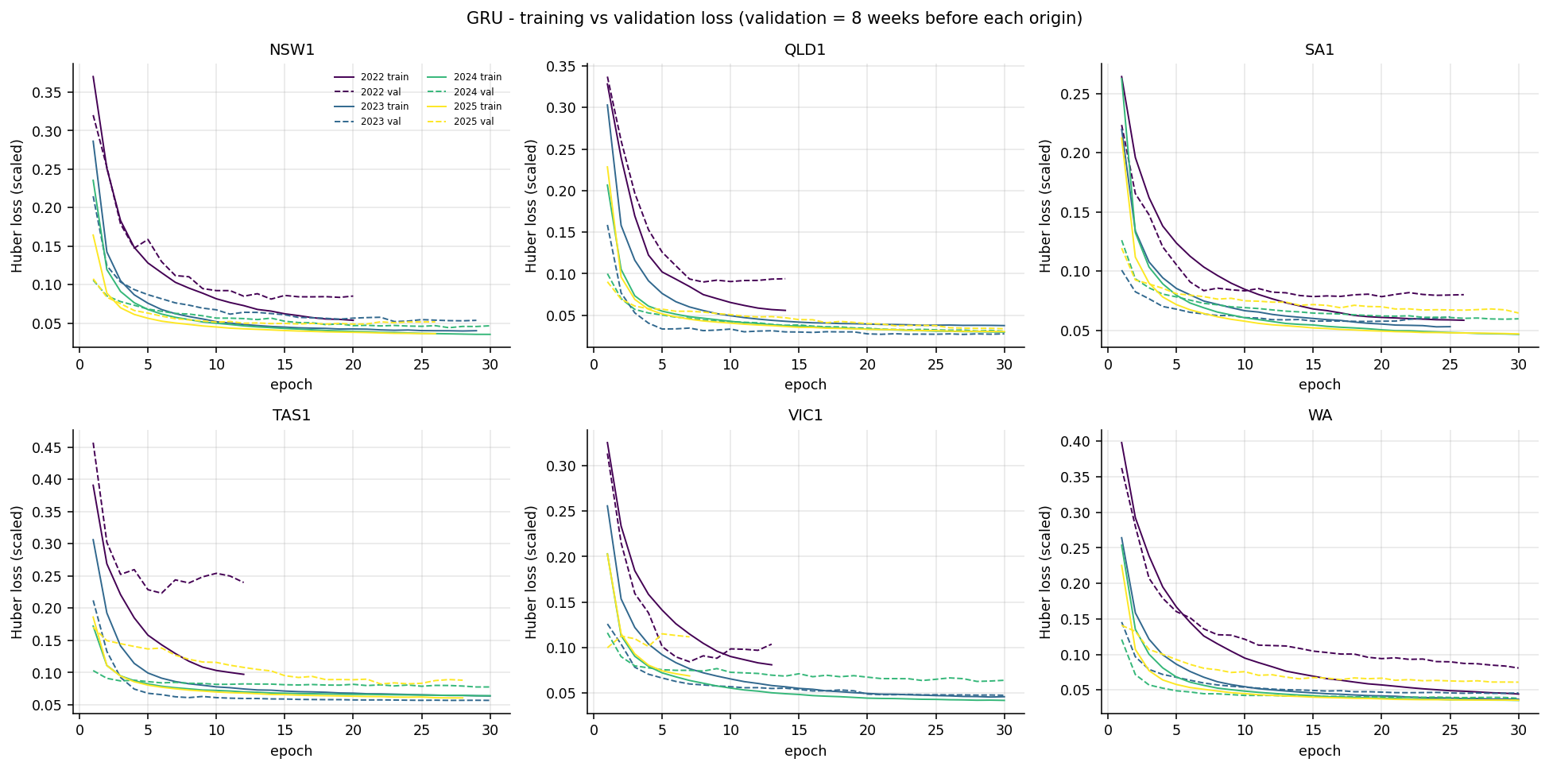
Figure 1. GRU training vs validation loss per region and origin (validation = eight weeks before each origin).
The curves show a GRU that is still improving slowly when the 30-epoch budget ends, but with validation loss almost flat over the last ten epochs. A longer budget would probably help a little, at a cost already about 25 times that of a Random Forest run; the GRU finished 3.2–26.4% worse than the previous champion in every region, so the budget is unlikely to change the decision. One VIC1 2025 fit selected epoch 1, a reminder that an eight-week validation block is a noisy guide.
Weather provenance matters directly for Sudip's area. Every backtest used origin-safe climatology on the horizon, so the weather ablation measures realistic value: weather-context features added error in the first week (about +6%) and reduced it from Days 8–30 onward (about −10%), with the largest benefit in WA.
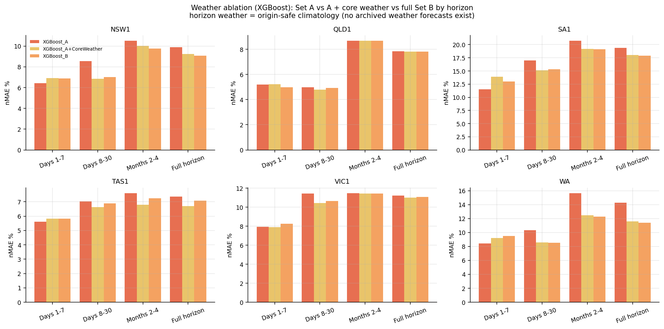
Figure 2. Weather ablation (XGBoost A vs A + core weather vs B) by lead band and region.

4. WP4 module delivered
Table 4. Module summary
Item | Detail
File | Individual_Code/WP4_Sudip_GRU_Training_Provenance.py (with shared wp4_contracts.py)
Main functions | gru_parameters(), build_gru_network(), split_train_validation(), fit_gru_scalers(), train_gru(), refit_gru(), learning_history(), convergence_flags(), capture_failure(), validate_weather_provenance(), validate_information_boundary()
Contract objects | SequenceBatch (from Suraj), NeuralScalerBundle, TrainingHistory
Integration target | Section S (_build_gru and training half of run_gru()), Section P (callbacks), _leakage_audit() in Section T
Equivalence result | 12/12 checks pass: parameters; 56-day validation without straddling; scalers fitted before the limit; provenance and boundary checks pass on clean data and catch a planted target leak; parameter counts equal for L = 336/672 and quick mode; identical seed gives identical trained weights

5. Collaboration, review and next steps
Table 5. Issues from GitHub_Issues/ (package numbers)
Package issue | Title | Sudip's role | Branch
05 | GRU training and provenance safeguards | Owner (Suraj reviews) | wp4/sudip-gru-training
06 | GRU pair integration review | Co-owner with Suraj | review only
08 | Leakage / information-boundary review | Primary (Suraj reviews) | follow-up on own branch
12 | Production model hand-off specification | Co-primary with Suraj | wp4/production-handoff

- Map each DESIGN_CONTROL row of leakage_audit.csv to a named executable check (Issue 08; draft mapping in WP4_Code_Traceability.md).
- Review Suraj's sequence PR, including the sentinel test, before approval.
- Specify the production weather policy: genuine forecast weather where available, climatology beyond it, never labelled as a forecast (Issue 12).

6. Professional reflection
Sudip's earlier work on source quality and weather vintages shaped the GRU's training design: the central question was not only "how well does it fit?" but "what could it have known on the forecast date?". The weather and information-boundary checks answer that question in code rather than in prose, and the planted-leak test shows the checks actually catch a failure. The SARIMAX failures from his earlier area are a related lesson: a model that diverges over a long horizon should be recorded and explained, not quietly removed. (Reflection to be confirmed and personalised by the student before submission.)

